

**USER’S**

**MANUAL**

*Webpage Implementation*

**for ABC Learning Centre**

Prepared by: Daniel Seah

May, 2019

**Revision Sheet**

|  |  |  |
| --- | --- | --- |
| **Release No.** | **Date** | **Revision Description** |
| Version 0 | 31/05/2019 | Created User Document |
|  |  |  |
|  |  |  |
|  |  |  |
|  |  |  |
|  |  |  |

**USER'S MANUAL**

**TABLE OF CONTENTS**

Page #

1.0 GENERAL INFORMATION 1-1

1.1 System Overview 1-1

2.0 SYSTEM SUMMARY 2-1

2.1 System Configuration 2-1

3.0 GETTING STARTED 3-1

3.1 Setting up Server 3-1

3.2 Placeholder 3-4

3.3 Navigating Around the Webpages 3-4

**1.0 GENERAL INFORMATION**

# GENERAL INFORMATION

## 1.1 System Overview

The world today trades vast amounts of information through the internet. In the past, static webpages were presented to users. Such conventional methods required large amount of files to be present on the server which made maintenance tedious and difficult. Pages had to be constantly refreshed for new content to be displayed.

Today, however, with the presence of modern tools such as JavaScript and its libraries, Single Page Application (or SPA) have become an adopted approach to presenting information. SPAs, in contrast to conventional methods, only has a main page loaded. Additional content, which are small parts of webpages are then requested from the server when needed via Asynchronized Javascript and XML (Ajax). The newly received information replace the original content on the main page. No refreshes occurs during this time.

The webpages supplied to ABC Learning Centre uses a SPA to provide information. This SPA is hosted on a server (Apache) to work.

**2.0 SYSTEM SUMMARY**

# SYSTEM SUMMARY

## 2.1 System Configuration

The webpages consists of the main page content with its categories, along with images, stylesheets and scripts to utilize Javascript. These files are to be hosted on a server where the webpages will function.

**3.0 GETTING STARTED**

# GETTING STARTED

## 3.1 Setting up MySQL

We first start by running “MySql-setup.exe”. This will begin the installation of MySQL.

-Select “Typical” installation then click the “Next >” button

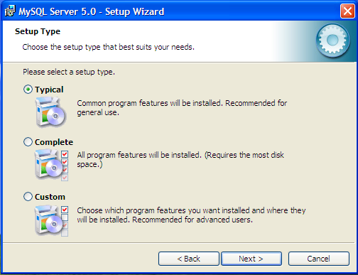

-Click the “Install” button to begin installation

-Once the installation completes click “Next >” twice

-Now insure “Configure the MySQL Server now” check box is selected and press “Finish”

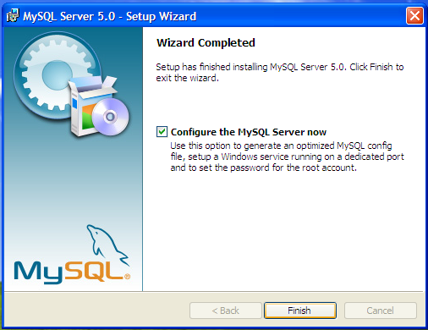

-Click “Next >” on the Configuration Wizard to begin the configuration

-Select the radio button “Standard Configuration” and click “Next >”

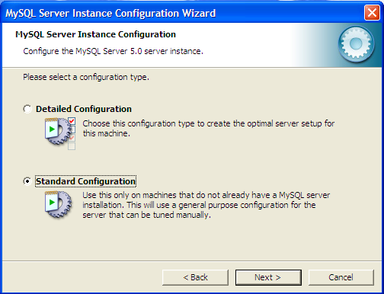

-Ensure “Install As Windows Service” checkbox is checked, the service name is “MySQL” and “Launch the MySQL Server automatically” is checked. Also make sure “Include Bin Directory in Windows PATH” checkbox is checked. Click “Next >” to continue

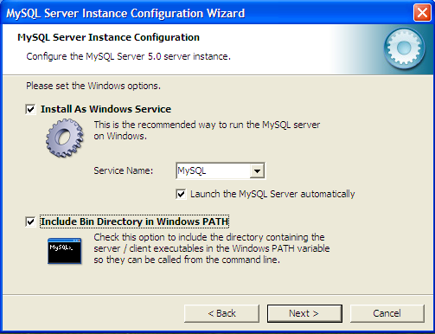

-Now make sure “Modify Security Settings” and “Enable root access from remote machines” are the only two check boxes selected. Input the desired password that only the administrator will know. This password will be used for adding and removing MySQL users as well as setting up the database tables. The username for the root account is “root” and this account should NOT be used to log in from the DSS Database Suite client program. DSS employees should use the accounts created in 3.3 as their login accounts. Click “Next >” then “Execute” to setup the MySQL server with the specified settings.

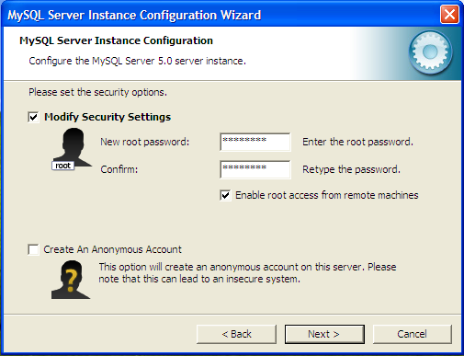

-Click “Finish” once the processing is complete.

After the installation is complete you will need to use the MySQL Command Line Client (which can be found under Start Menu -> MySQL -> MySQL Server 5.0) Once the command prompt comes up you will need to enter the root password you set in the MySQL setup. From this command line you will be able to complete setting up the database tables and adding MySQL Users

## 3.2 Going to the Main Page

The database is like a container for all of the information used in this application. We need to first add a database and in this example we will use DSS_MAIN as the name of the database, but anything can be used. To create the database we use the following command:

CREATE DATABASE `DSS_MAIN`;

Note that the ticks surrounding the work DSS_MAIN are the ticks located to the left of the number one (1) on a standard QEWRTY keyboard.

## 3.3 Navigating Around the Webpages

Once the database has been created we need to add tables to it. Database tables are used to store information for every student. They can be thought of as spreadsheets where each row is a record that corresponds to a specific student or piece of equipment. The database uses only two different tables to operate. We need one table for all of the student’s information and another table for all equipment used by students. To create the tables the following commands should be used.

This first command creates the table for student information. The name DSS_MAIN should be changed to whatever you named the database in step 3.2 and the name student_information can be changed to the desired table name for the student’s information.

## CREATE TABLE `DSS_MAIN`.`student_information` (`DawgTag` INT (9) NOT NULL, `SSN` VARCHAR (11) NOT NULL, `FirstName` CHAR (50), `MiddleInitial` CHAR (2), `LastName` CHAR (50), `Birthdate` VARCHAR (10), `Sex` VARCHAR (6), `Ethnicity` VARCHAR (15), `Status` VARCHAR (13), `MaritalStatus` VARCHAR (9), `Class` VARCHAR (9), `HousingAssistance` VARCHAR (5), `Major` VARCHAR (50), `LocalAddress` VARCHAR (50), `LocalCity` VARCHAR (50), `LocalState` VARCHAR (15), `LocalZip` VARCHAR (10), `LocalPhone` VARCHAR (14), `CellPhone` VARCHAR (14), `HomeAddress` VARCHAR (50), `HomeCity` VARCHAR (50), `HomeState` VARCHAR (15), `HomeZip` VARCHAR (10), `HomePhone` VARCHAR (14), `EmailAddress` VARCHAR (50), `TextConversion` VARCHAR (3), `Wheelchair` VARCHAR (3), `War` VARCHAR (15), `Military` VARCHAR (3), `DHSAffiliation` VARCHAR (3), `DSSWorker` VARCHAR (50), `PrimaryCode` VARCHAR (50), `PrimaryDisability` VARCHAR (100), `SecondaryDisability` VARCHAR (100), `SummerService` VARCHAR (512), `FallService` VARCHAR (512), `SpringService` VARCHAR (512), `FiscalYearService` VARCHAR (512), `Disabled` VARCHAR (3), `CaseStatus` VARCHAR (6), `CaseNotes` LONGTEXT, PRIMARY KEY(`DawgTag`), UNIQUE(`DawgTag`)) TYPE = InnoDB;

The next command is used to create the equipment table. Once again you must change the name DSS_MAIN to whatever was named in step 3.2 and may change the table name of equipment to whatever is desired. The command is this:

## CREATE TABLE `DSS_MAIN`.`equipment` (`DawgTag` INT (9) NOT NULL, `EquipmentName` VARCHAR (256), `SIUCNumber` INT (10) UNSIGNED, `DateLoaned` VARCHAR (10), `DateDue` VARCHAR (10), `DateReturned` VARCHAR (10), `Notes` VARCHAR (128), `ID` VARCHAR (25) NOT NULL, PRIMARY KEY(`ID`), UNIQUE(`DawgTag`,`ID`)) TYPE = InnoDB;

Note that the only fields that can be changed in the previous two commands are the two words immediately after the word TABLE. In this case DSS_MAIN and wither student_information or equipment. The other fields are the names of the columns that are necessary to the function of the client program.

## 